5/27/2021

**CO-LAB 10**

**Progress Report**

**AMINA QADEER**

**CE-42-A**

**359607**

**CO-LAB 10**

Question 1:

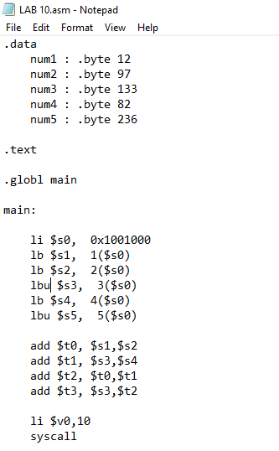#Question 1- CO-LAB 10

.data

num1 : .byte 12

num2 : .byte 97

num3 : .byte 133

num4 : .byte 82

num5 : .byte 236

.text

.globl main

main:

li $s0, 0x1001000

lb $s1, 1($s0)

lb $s2, 2($s0)

lbu $s3, 3($s0)

lb $s4, 4($s0)

lbu $s5, 5($s0)

add $t0, $s1,$s2

add $t1, $s3,$s4

add $t2, $t0,$t1

add $t3, $s3,$t2

li $v0,10

syscall

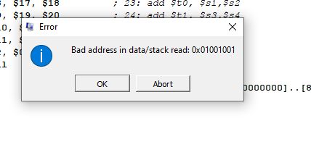

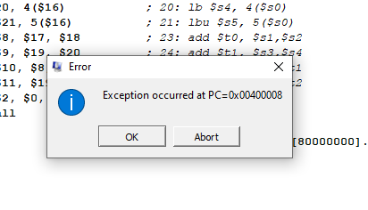

**I kept on clicking OK. And finally got this output**:

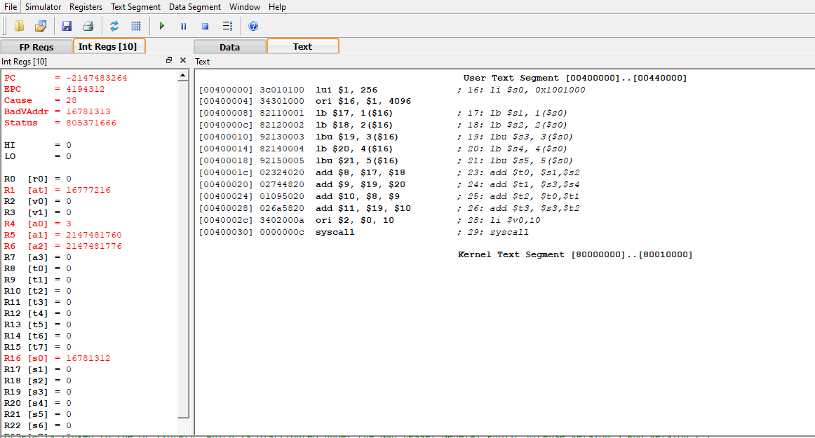

Secondly, I read two pdfs from Google to make more understanding between difference between Load byte and Load word instructions. I read and understood the whole Lab manual.

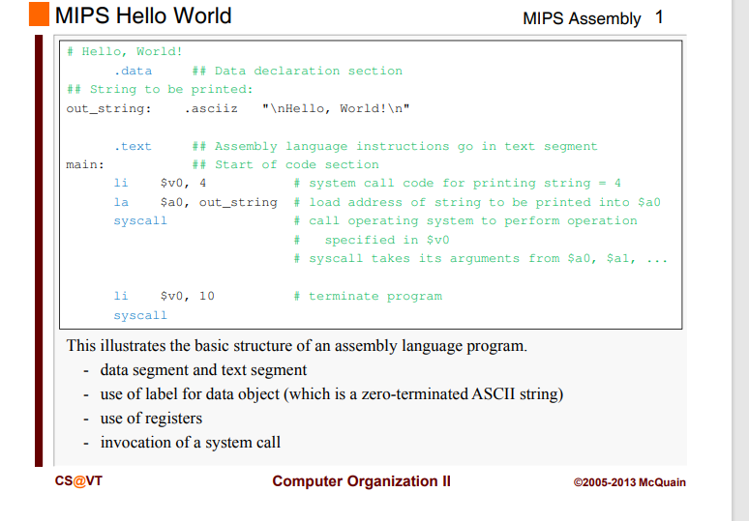

And another document to understand about the Control instructions in MIPS.

Types of move instructions and there uses with examples.

**THE END**